Task 1:

1. Systems IP Address

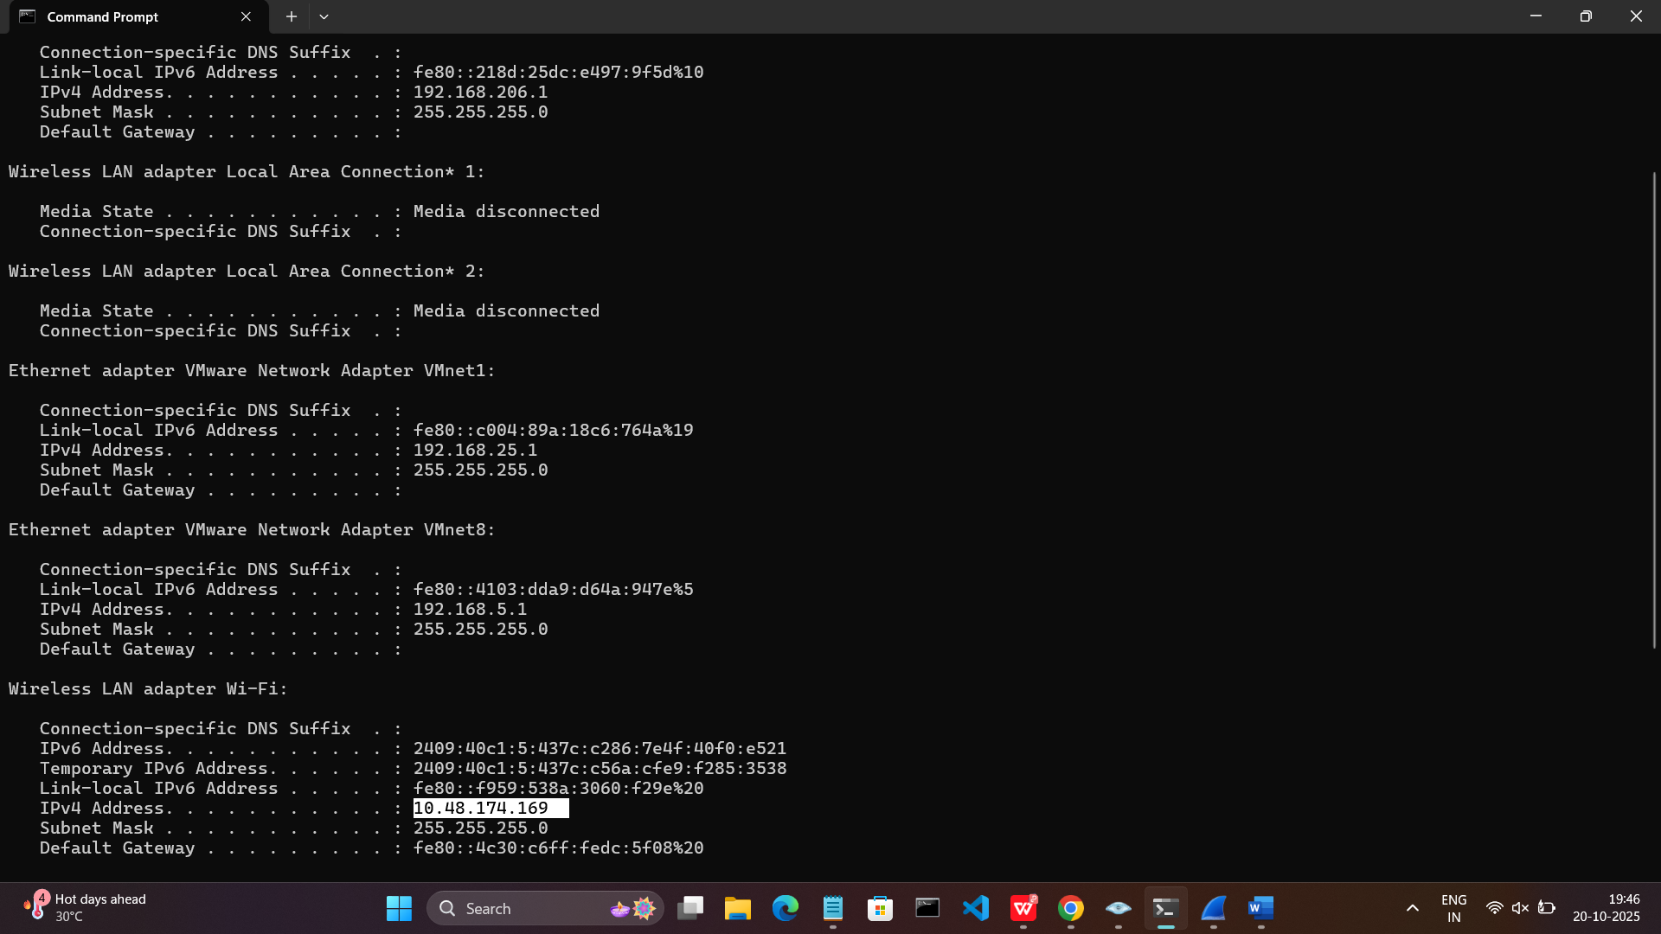

1. Zenmap Scan

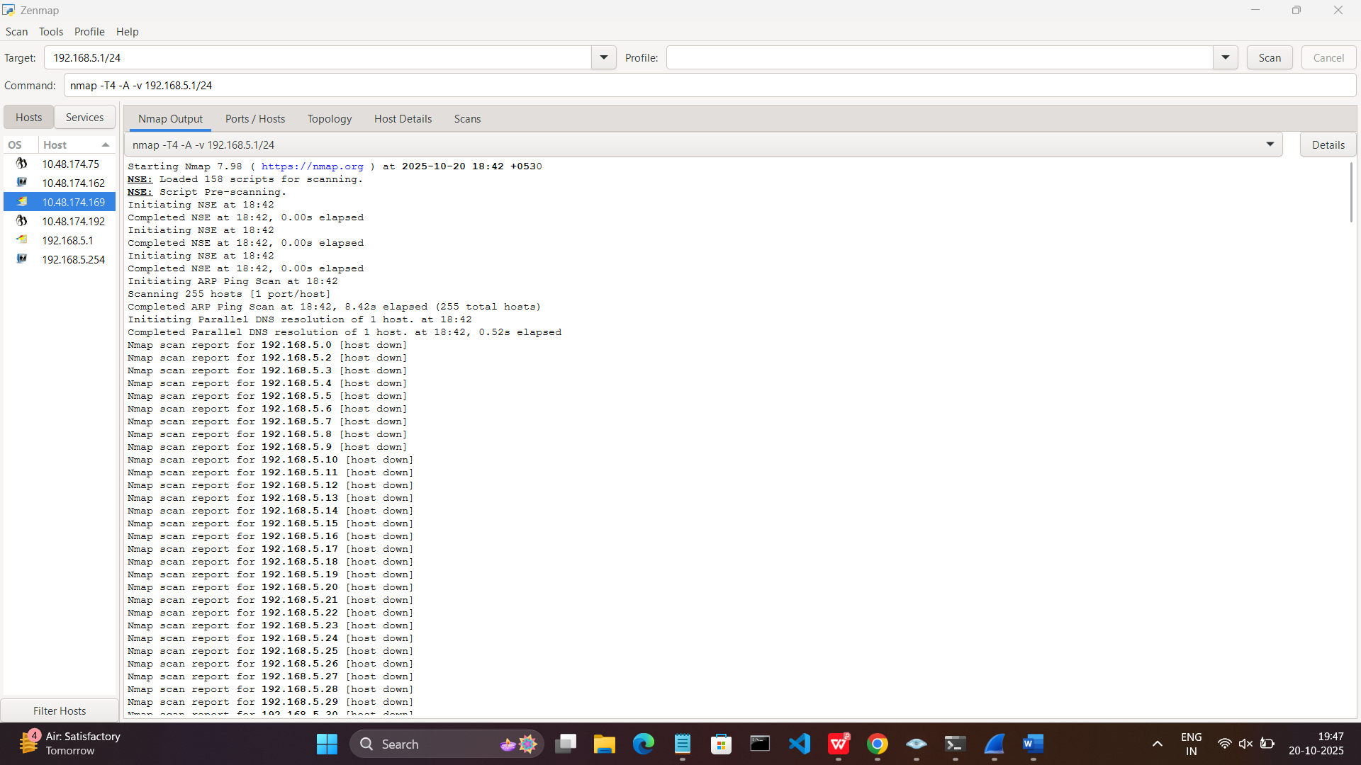

1. Open Ports

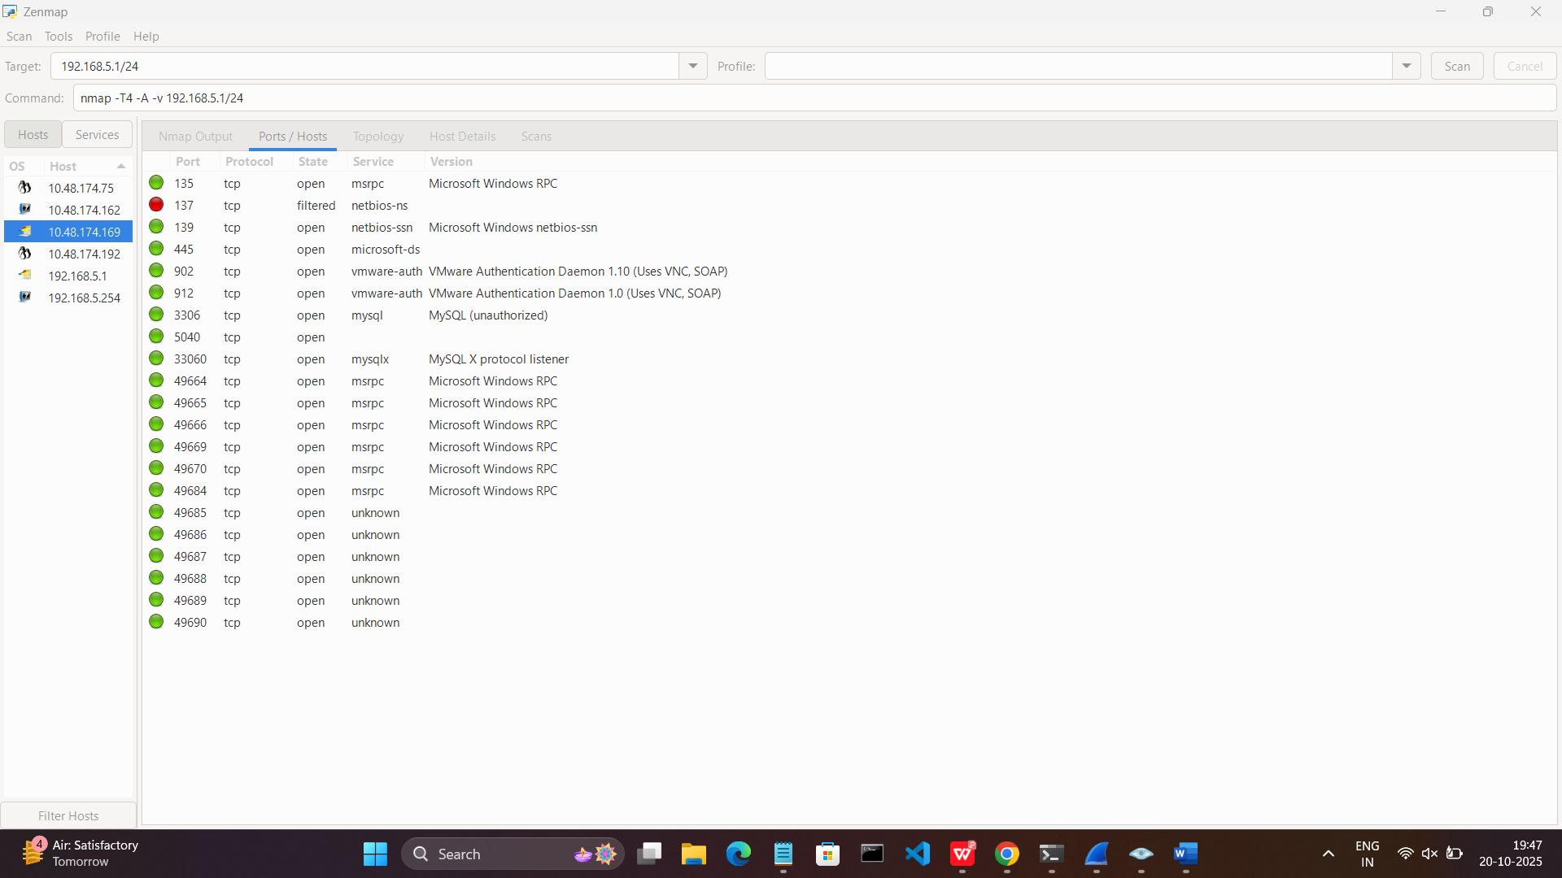

1. Potential Risks from open ports
2. Microsoft Windows RPC (ports 135, 49664-49670, 49684): RPC is used for remote management. If vulnerable, it could allow unauthorized access or exploitation.
3. MySQL (ports 3306, 5040, 33060): Open MySQL ports can be a risk if not secured properly, potentially allowing unauthorized DB access.
4. VMware Authentication Daemon (ports 902, 912): These services manage remote access to VMs. If not secured, could lead to unauthorized VM access.
5. Unknown services on high ports (49685-49690): Unknown services can be a risk as you don't know what's running or if it's secure.
6. Wireshark scan

